NAIA-ATA Athletic Trainer of the Year Award
RECEIPT DEADLINES

TO CONFERENCE: JUNE 15
TO NATIONAL OFFICE: JULY 15

SUBMIT BY MAIL
NAIA NATIONAL OFFICE
120 W. 12th Street, Suite 700
Kansas City, Mo. 64105

SUBMIT BY EMAIL
awards@naia.org
Recognizes outstanding certified athletic trainers

Description
This award recognizes an athletic trainer who provides athletic training services to an NAIA institution that has distinguished themselves as a model of the profession of athletic training in personal conduct and professional allied health service to athletes.

Criteria
- Certified and/or licensed athletic trainer.
- Must provide athletic training services to NAIA athletics as an employee of that institution or through a healthcare entity.
- Has not received the award in the past three years.

Required Nomination Materials
- Official nomination form
- Current high-resolution photo
- Résumé or CV

Selection
- The NAIA National Office will forward all nominations to the NAIA-Athletic Trainers Association Awards Committee.
- After selection is made by the appropriate committee, the National Office officially notifies the national winner a week before NAIA National Awards Day in September.

Recognition
The national award recipient is announced publicly during NAIA National Awards Day in September and will be presented with a certificate and recognized at the annual meeting of the NAIA-ATA.

Question Contact
SAED@naia.org or 816.595.8114

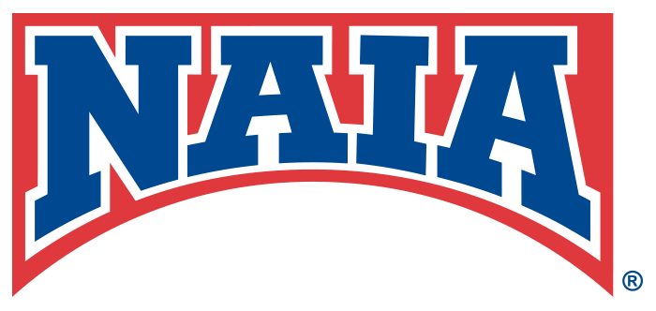
NAIA-ATA Athletic Trainer of the Year Award
National Nomination Form
RECEIPT DEADLINES

TO CONFERENCE: JUNE 15
TO NATIONAL OFFICE: JULY 15

SUBMIT BY MAIL
NAIA NATIONAL OFFICE
120 W. 12th Street, Suite 700
Kansas City, Mo. 64105

SUBMIT BY EMAIL
awards@naia.org
Complete nomination includes:
This official nomination form
Current high-resolution photo
Resume or CV

Nominee’s Information
Name:
Pronunciation:
Title:
Email: |  | Phone:
Institution: |  | Conference:

1. Does the nominee meet each of the criteria? (Fields will expand as answer is entered.)
Certified and/or licensed athletic trainer.

Must provide athletic training services to NAIA athletics as an employee of that institution or through a healthcare entity.

Has not received the award in the past three years.

2. How has the nominee distinguished herself/himself?

3. How has the nominee brought honor to their institution, the Athletic Training profession and/or the NAIA?

4. What unique personal and professional qualities define the nominee?

Nominator Information
Name: |  | Title:
Institution: |  | Phone:
Email:

